**Attendance System Using Face Recognition**

**TABLE OF CONTENTS**

1. Introduction.......................................................................................................... 1
   1. Purpose........................................................................................................... 2
   2. Objectives....................................................................................................... 2
   3. Scope.............................................................................................................. 3
2. Problem Definition…………………................................................................... 4
3. Proposed System………....................................................................................... 5
   1. Features and Functionality…………………………………………………. 5
4. Project Outcomes.................................................................................................. 6
5. Software Requirements ........................................................................................ 8
6. Project Design........................................................................................................10
7. Conclusion..............................................................................................................16

**Chapter 1**

**Introduction**

Attendance systems of old practices are not quite efficient nowadays for keeping track on student’s attendance. Students enrollment in schools and colleges increases every year and taking each student's attendance plays a very vital role. So, it is necessary to discuss the effective system which records the attendance of a student automatically.

A face recognition system is very useful in life applications especially in security control systems. Hence, the main objective of this project is to develop a face recognition based automated student attendance system. Maintaining attendance is very important in all the schools/colleges for checking the performance of students. Every school/college has its own method in this regard. Some are taking attendance of students manually using attendance registers or marking attendance sheets or file based approaches and some have adopted the methods of automatic attendance using some biometric techniques. But in these methods, students have to wait for a longtime in make a queue at the time they enter inside the classroom. Many biometric systems are available in the market but the key authentications are the same in all of their techniques. Every Biometric system consists of an enrollment process in which the unique features of a person are stored in the database and after that, there are some processes of identification and verification of the person. These two processes compare the biometric feature of a person with a previously stored template captured at the time of enrolment of a student.

Biometric Templates can be of many types like Fingerprints, Eye Iris, voice etc. Our system uses the face recognition approach for the automatic attendance of the students in the classroom environment. The purpose of developing the new attendance management system is to computerize the traditional methods of taking attendance. Therefore, in order to drag the attention of students and make them interactive in observing technologies, we try to move on to the latest upcoming trends on developing attendance systems. To track the attendance of the students, we are trying to develop the attendance management system. Attendance Management system is to count the number of students and urge students to attend the classes on time, and mark attendance without any manual work.

Usually, a roll-call is taken to determine whether the student is present in the class or not, which usually wastes a lot of time. In recent years, with the emerging technology and with the development of deep learning, face recognition has made great achievements, which leads us to a new way of thinking to solve the problem of student's enrollment. So, in order to save time, the idea to count the number of students in a class automatically based on face recognition is incorporated. This system is developed by using face recognition technique which is used to detect the face of an individual. There are many different face recognition algorithms introduced to increase the efficiency of the system.

In order to achieve better performance, the test images and training images of this proposed approach are limited to frontal and upright facial images that consist of a single face only. The test images and training images have to be captured by using the same device to ensure no quality difference. In addition, the students have to register in the database to be recognized.

**1.1. Purpose**

* Automated attendance marking system using face recognition simplifies the attendance marking system without manual intervention.
* To create an effective platform that will consume less time.

**1.2. Objectives**

* The main objective of this project is to develop an automated face recognition based student attendance system.
* To detect the face segment from the video frame.
* To extract the useful features from the face detected.
* To classify the features in order to recognize the face detected.
* To record the attendance of the identified student.

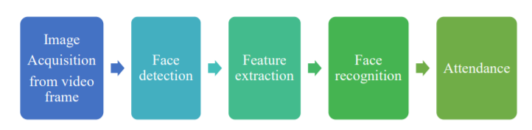

Figure 1. Block Diagram of the General Framework

**1.3. Scope**

* In this software, the Admin can add new students and manage that students information.
* This application is efficient so that individual’s faces are recognised.
* When the face is detected the details of students get updated automatically.
* This application Utilizes video and image processing to provide inputs to the system.
* The system is convenient and secure for the users.
* It saves their time and efforts, especially if it is a lecture with a huge number of students.
* Ultimately, this framework is the better and reliable solution from every perspective of time and security.
* After recognizing all the students present in the class an excel file is created living the attendance of the class with date.

**Chapter 2**

**Problem Definition**

Traditional student attendance marking techniques are often facing a lot of trouble. The face recognition student attendance system emphasizes its simplicity by eliminating classical student attendance marking techniques such as calling student names or checking respective identification cards. They not only disturb the teaching process but also cause distraction for students during exam sessions. Apart from calling names, the attendance sheet is passed around the classroom during the lecture sessions. The lecture class, especially the class with a large number of students might find it difficult to have the attendance sheet being passed around the class. Thus, a face recognition student attendance system is proposed in order to replace the manual signing of the presence of students which are burdensome and causes students to get distracted in order to sign for their attendance. Furthermore, the face recognition based automated student attendance system is able to overcome the problem of fraudulent approach and lecturers do not have to count the number of students several times to ensure the presence of the students.

Hence here we developed a real time operating student attendance system which means the identification process must be done within defined time constraints to prevent omission. The extracted features from facial images which represent the identity of the students have to be consistent towards a change in background, illumination, pose and expression. High accuracy and fast computation time will be the evaluation points of the performance.

**Chapter 3**

**Proposed System**

Following are the main components of the proposed system:

1. Student Registration :
2. marks student’s attendance via face
3. admin registers student’s details
4. Face Detection :
5. detects face via inbuilt camera\webcam
6. Face Recognition
7. Feature Classification :
8. categorize students after recognizing their faces
9. Feature Extraction :
10. withdraws details by cross-checking the details associated with the faces
11. Trainer Part :
12. clubs different images of the same person, to help in identification
13. Attendance management system
14. Automated Attendance marking
15. Attendance details of users

**3.1. Features and Functionality**

* It Reduces the number of touchpoints :

1. Facial recognition requires fewer human resources than other types of security measures, such as fingerprinting.
2. It also doesn’t require physical contact or direct human interaction.
3. Without making changes in excel or manual checking in the notebook it generates attendance lists.

* Time efficient :
  1. This system is effective and saves time and efforts of users.
  2. It saves the user's time in manually calculating attendance.
  3. Automatic data validation
* User friendly environment.
* Easy performance check.
  1. It saves attendance automatically by recognising the face.
* Data security and reliability :

1. Facial recognition also helps improve safety and security too.

**Chapter 4**

**Project Outcomes**

Admin:

* can login and create a new account.
* can add new student details, update details and delete details.
* can train data, view and download attendance.
* can cascade classifier for face detection.

User:

* can mark his/her attendance using face detection.

**Chapter 5**

**Software Requirements**

* **Python - Idle**

IDLE (Integrated Development and Learning Environment) is an integrated development environment (IDE) for Python. The Python installer for Windows contains the IDLE module by default.

IDLE can be used to execute a single statement just like Python Shell and also to create, modify, and execute Python scripts. IDLE provides a fully-featured text editor to create Python script that includes features like syntax highlighting, autocompletion, and smart indent. It also has a debugger with stepping and breakpoints features.

* **OpenCV** is a huge open-source library for computer vision, machine learning, and image processing. OpenCV supports a wide variety of programming languages like Python, C++, Java, etc. It can process images and videos to identify objects, faces, or even the handwriting of a human. When it is integrated with various libraries, whatever operations one can do in Numpy can be combined with OpenCV.
* The **Graphical User Interface (GUI)** is a form of user interface that allows users to interact with electronic devices through graphical icons and audio indicators such as primary notation, instead of text-based user interfaces, typed command labels or text navigation. GUIs were introduced in reaction to the perceived steep learning curve of command-line interfaces (CLIs), which require commands to be typed on a computer keyboard.
* **Tkinter - Python GUI**

Tkinter is the standard GUI library for Python. Python when combined with Tkinter provides a fast and easy way to create GUI applications. Tkinter provides a powerful object-oriented interface to the Tk GUI toolkit.

* **Back End : MySQL Workbench**

MySQL Workbench is a visual database design tool that integrates SQL development, administration, database design, creation and maintenance into a single integrated development environment for the MySQL database system. It is the successor to DBDesigner 4 from fabFORCE.net, and replaces the previous package of software, MySQL GUI Tools Bundle. More features: SQL Editor, Performance monitoring, Data modeling, Database migration.

* **Database - mySQL**

MySQL is an [open-source](https://en.wikipedia.org/wiki/Open-source_software) relational database management system (RDBMS).Its name is a combination of "My", the name of co-founder Michael Widenius's daughter, and "SQL", the abbreviation for Structured Query Language. A relational database organizes data into one or more data tables in which data types may be related to each other; these relations help structure the data. SQL is a language programmers use to create, modify and extract data from the relational database, as well as control user access to the database. In addition to relational databases and SQL, an RDBMS like MySQL works with an operating system to implement a relational database in a computer's storage system, manages users, allows for network access and facilitates testing database integrity and creation of backups. MySQL is free and open-source software under the terms of the GNU General Public License, and is also available under a variety of proprietary licenses.

* **Laptop Camera**
* **Local Binary Pattern Histogram (LBPH) algorithm**

LBPH is based on a local binary operator. It is widely used in facial recognition due to its computational simplicity and discriminative power. It's a part of OpenCV.

The steps involved to achieve this are:

a. creating dataset

b. face acquisition

c. feature extraction

d. classification

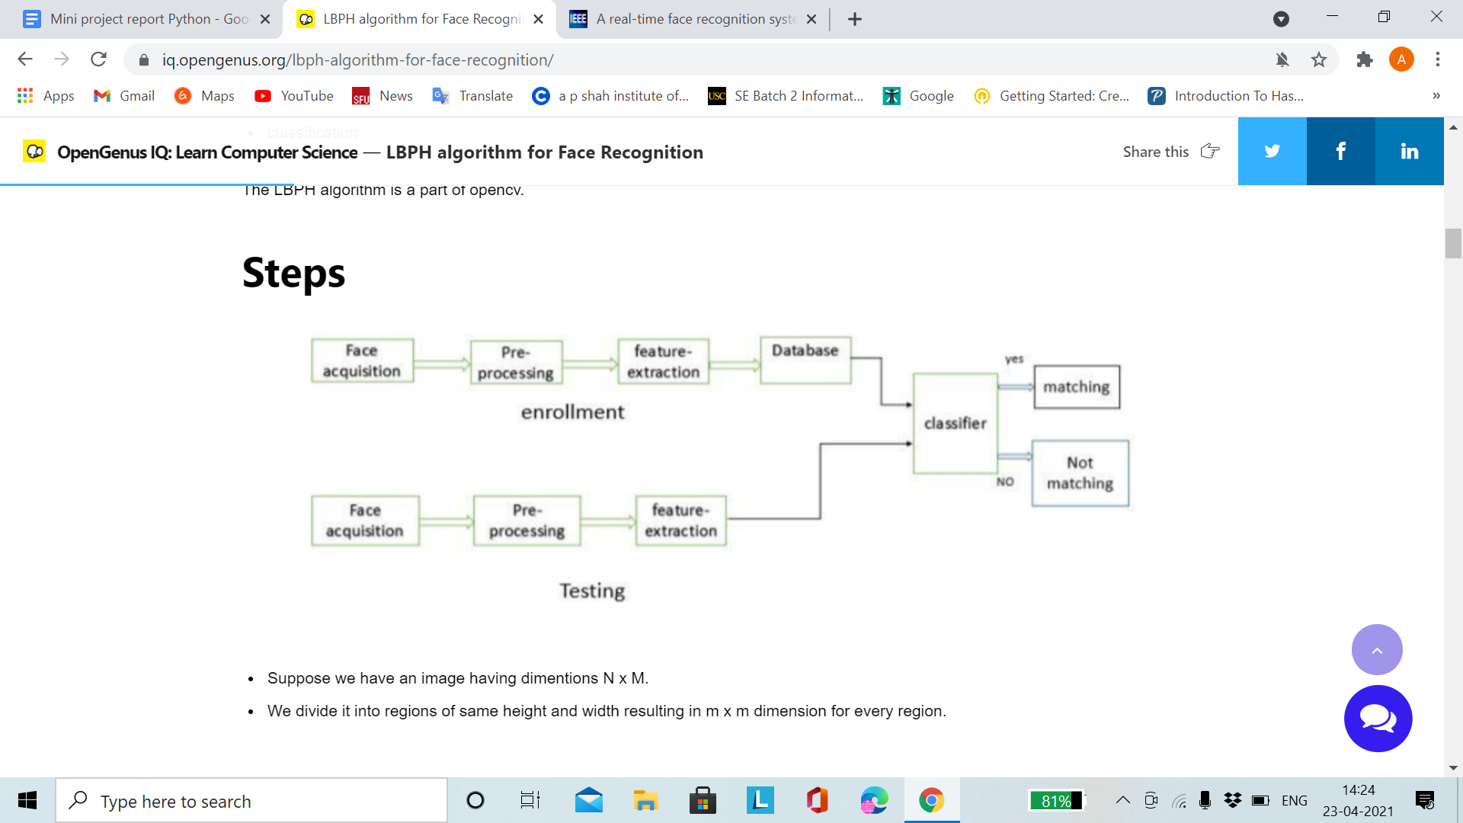

Local binary operators are used for every region. The LBP operator is defined in a window of 3x3.

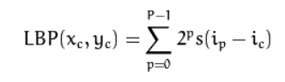

Here '(Xc,Yc)' is the central pixel with intensity 'Ic' and 'In' being the intensity of the neighbor pixel.

Using median pixel value as threshold, it compares a pixel to its 8 closest pixels using this function.

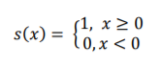

If the value of neighbor is greater than or equal to the central value it is set as 1 otherwise it is set as 0. Thus, we obtain a total of 8 binary values from the 8 neighbors.

The idea here is to align an arbitrary number of neighbors on a circle with a variable radius. This way the following neighborhoods are captured:

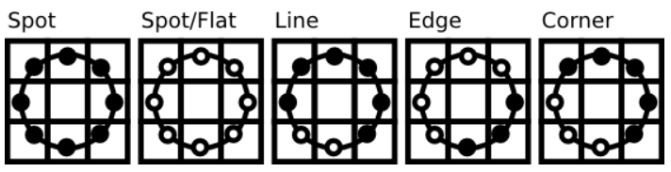

For a given point (Xc,Yc) the position of the neighbor (Xp,Yp), p belonging to P can be calculated by:

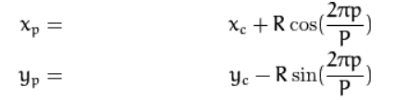

Here R is the radius of the circle and P is the number of sample points. If a point coordinate on the circle doesn’t correspond to image coordinates, it get’s interpolated generally by bilinear interpolation. **Bilinear Interpolation** is a resampling method that uses the distance weighted average of the four nearest pixel values to estimate a new pixel value :

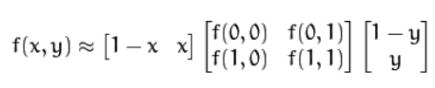

The LBP operator is robust against monotonic gray scale transformations. After creation of histogram for each region all the histograms are merged to form a single histogram and this is known as the feature vector of the image.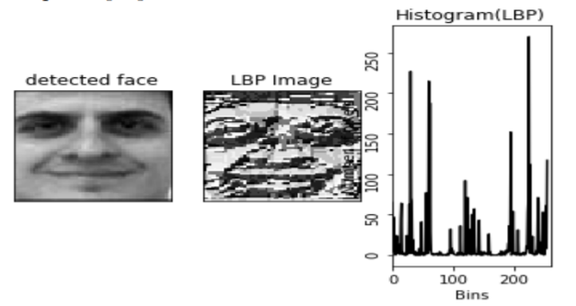

Now we compare the histograms of the test image and the images in the database and then we return the image with the closest histogram.  
( This can be done using many techniques like euclidean distance, chi-square, absolute value etc ).

The Euclidean distance is calculated by comparing the test image features with features stored in the dataset. The minimum distance between test and original image gives the matching rate.

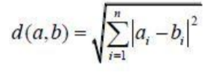

As an output we get an ID of the image from the database if the test image is recognised. LBPH can recognise both side and front faces and it is not affected by illumination variations which means that it is more flexible.

**Chapter 6**

**Project Design**

* **User side :**

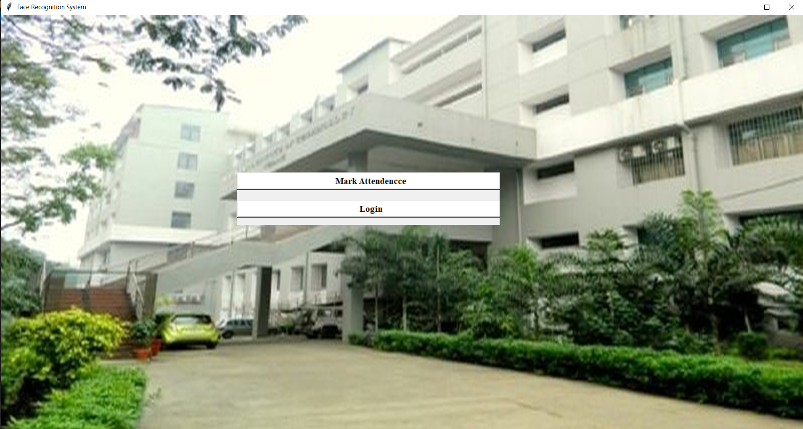

once user clicks on mark attendance the following page opens:

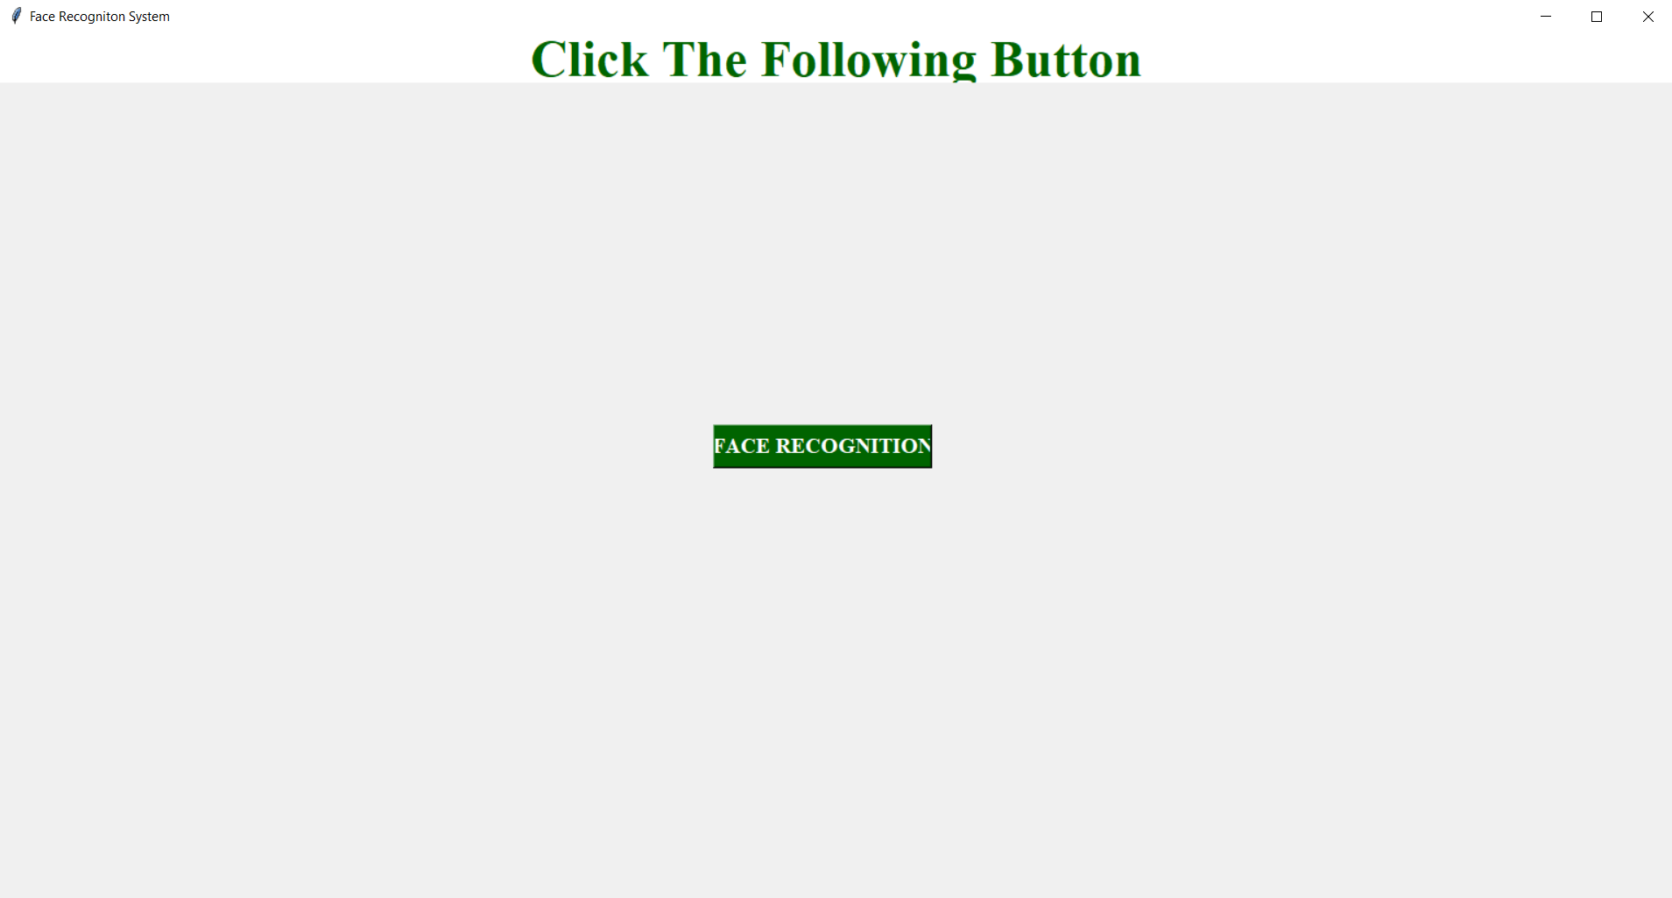

by clicking on face recognition button user/student can mark their attendance

* **Admin side:**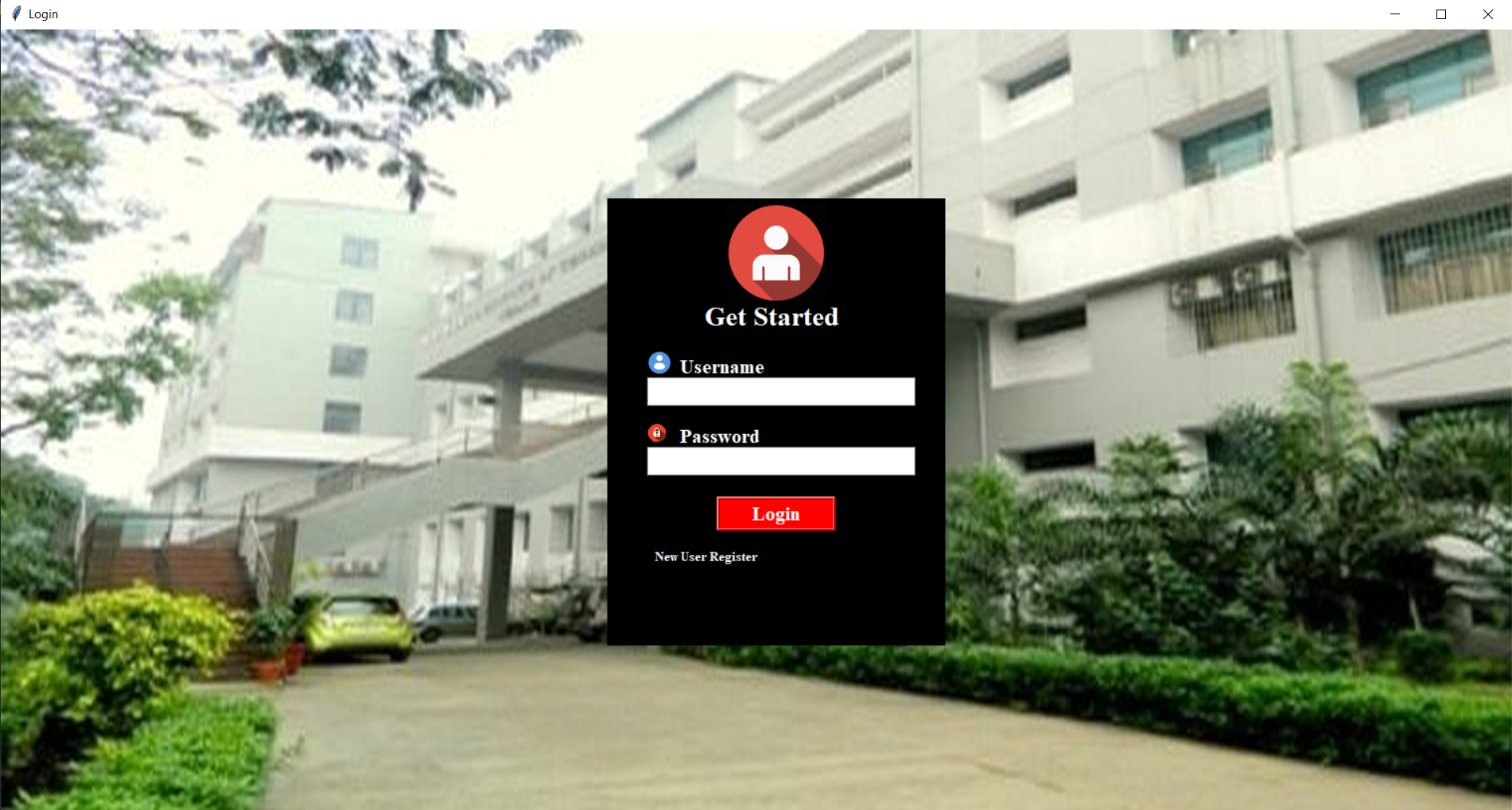

once admin is successfully logged in they can see main page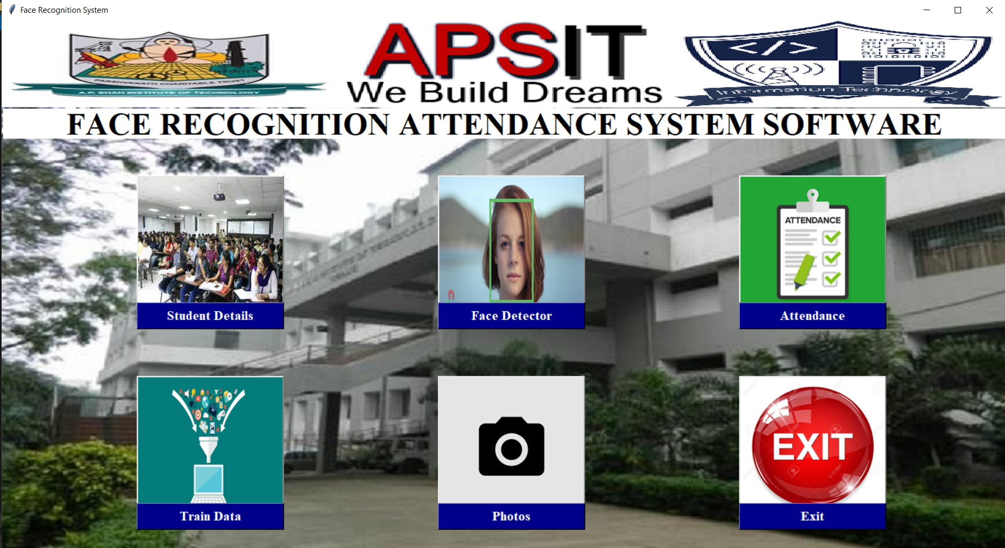

* Student details :
* Attendance :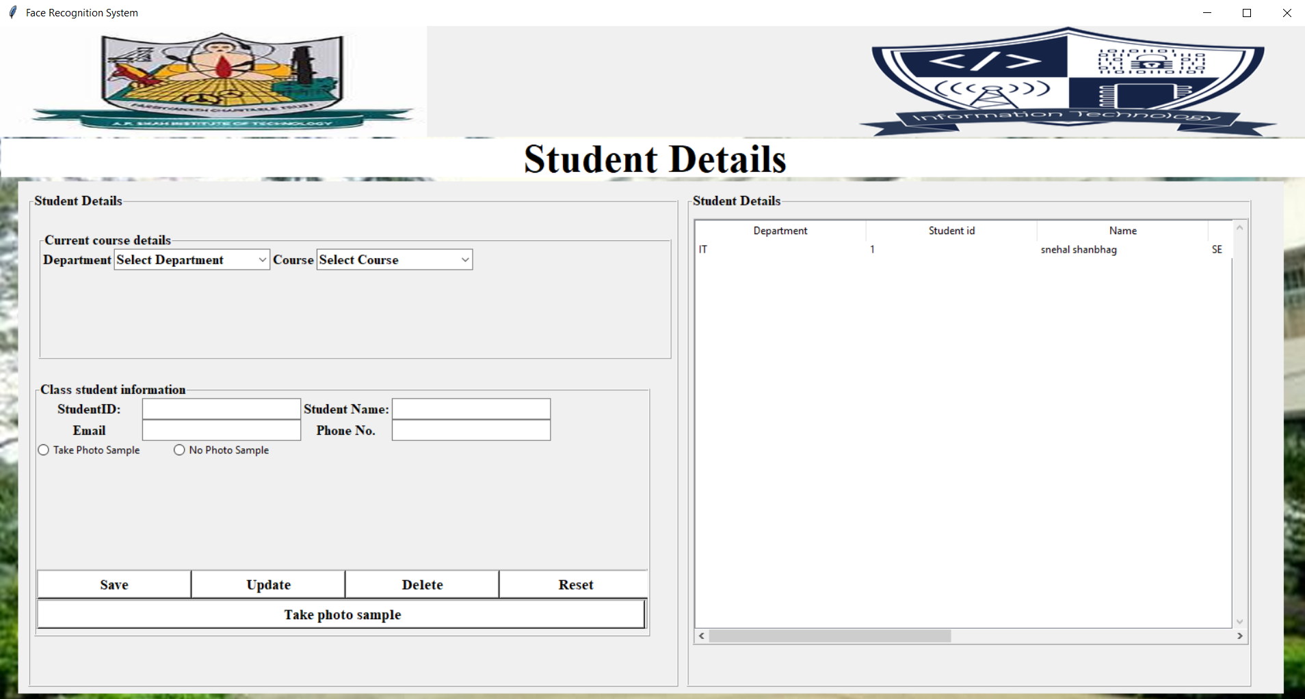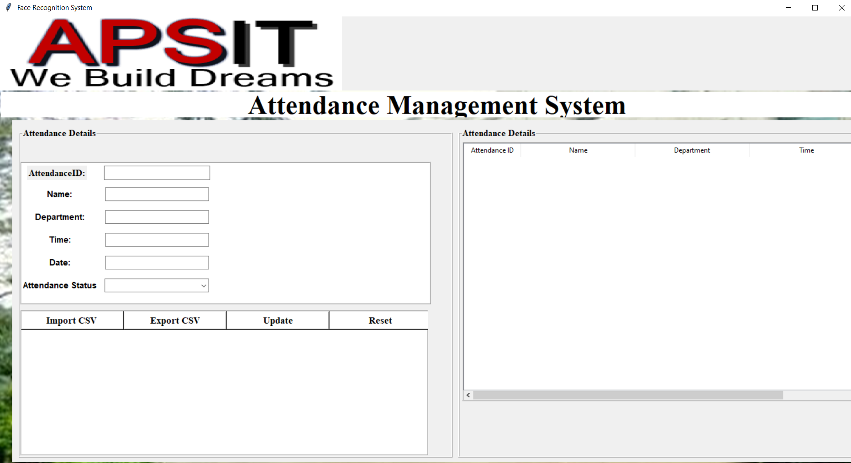
* For training the machine with data set:

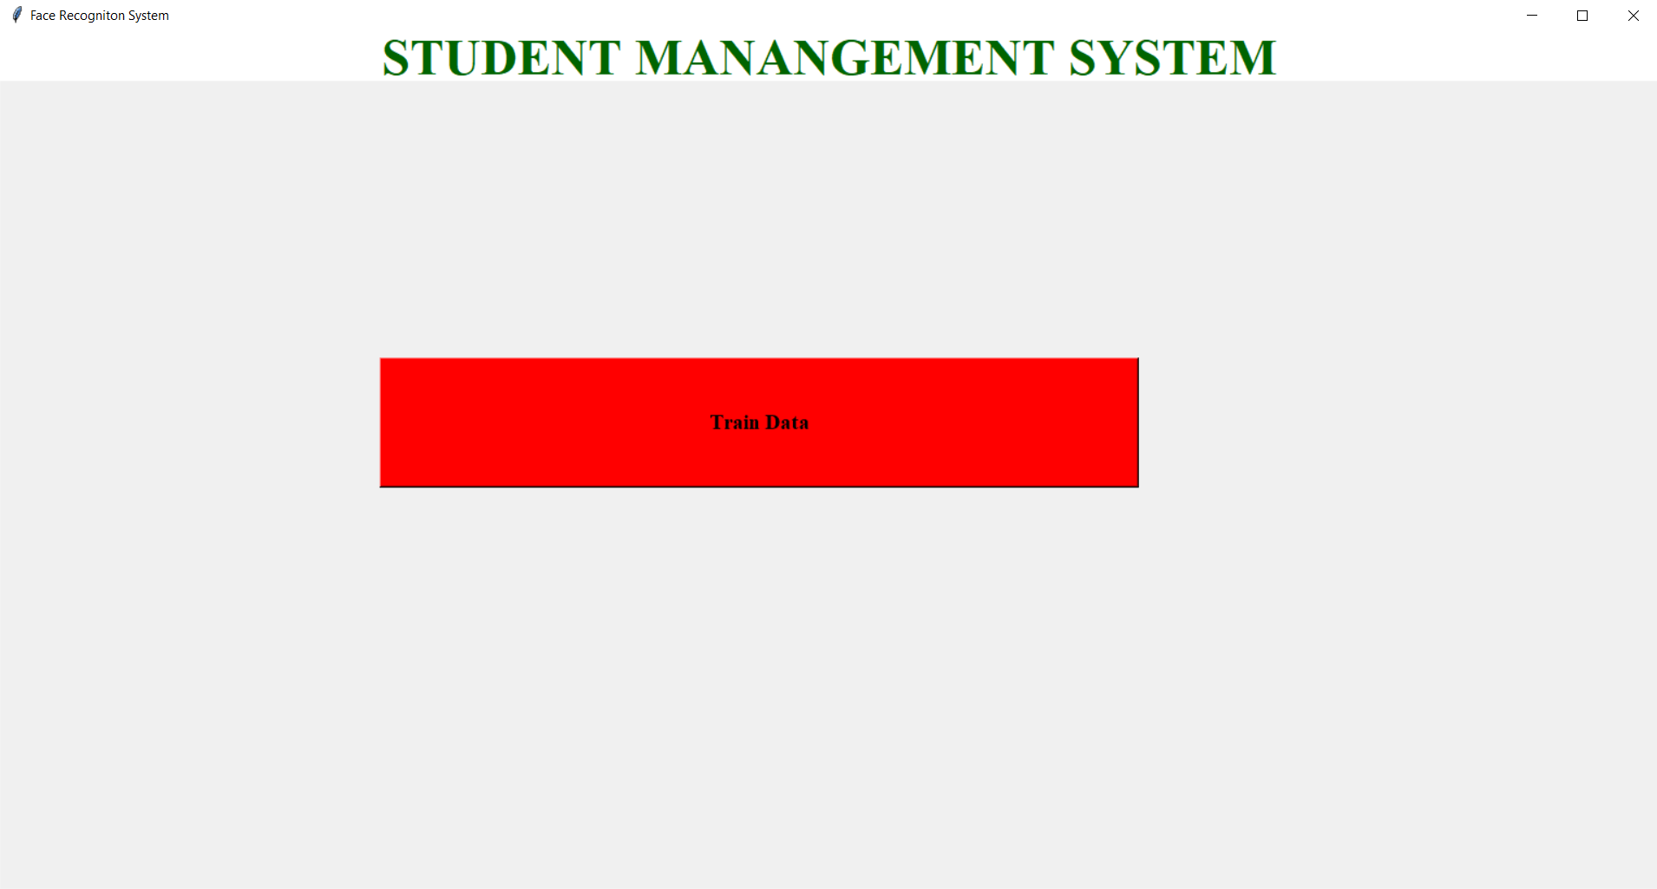

**Chapter 8**

**Conclusion**

In this approach, a face recognition based automated student attendance system is thoroughly described. The proposed approach provides a method to identify the individuals by comparing their input image obtained from image frame with respect to train image. This proposed approach is able to detect and localize faces from an input facial image, which is obtained from the recording image frame. Besides, it provides a method in the pre-processing stage to enhance the image contrast and reduce the illumination effect. The accuracy of this proposed approach is 100 % for high-quality images, 92.31 % for low-quality images.